Abstract— this report is to summarize the work we have done for our Group Project. This group project is to make ATM Software system. This is the computer based Software System, connected to a secure network, that offers, as basic functions to users, access to bank account. (Check balance, bank transfers, deposit and withdrawal) [1] In order to finish this project we made a team of 3 members and we used GitHub collaboration platform to work as effective team for this project. Our GitHub Repository Address is https://github.com/Team-1111/bankbankatm. Also we used Git as Version Control System to work efficiently. In this report I will explain how we work as a team to finish this group project and what is my involvement, contribution to the design, specification and how I influenced the technical requirements of the project. In this report, I will explain the ATM System Description and functional and non- functional Requirements. Also, I will try my best to explain how system works with help of UML diagrams. But, I will show some UML diagrams instead of all the UML diagram we did.
Final Report for Group Project (Bank ATM Software System)
ALI IRUFAAN,
Zhejiang Normal University,
Email: irufaan0121@gmail.com,
Student No. 201532120135,
Object Orientated Analysis and Design.

Keywords—OOAD, ATM Machine, UML Diagram, Object Orientated, Complexity

INTRODUCTION
This group project to is to build ATM system using GitHub collaboration platform and version control system. In my team there are two Chinese student worked with me. Basically, first days in this project we studied how to use GitHub and version control system which is Git. However, those Chinese students English are not enough to understand how whole GitHub works. Therefore, I am the one who assigning the tasks, manage the GitHub works, like making milestones, open project and write all the requirements, functionalities even though I am not the team leader. Basically, I did most of the theory part of the project but we usually have team meeting once a week in order to discuss the work we did so far and the works need to be done. Moreover, I also contributed my works on making UML diagrams and generating codes for UML diagrams. First of all, let me explain what our project is about by explaining system description, functional requirements, and Non-Functional requirements of ATM system.
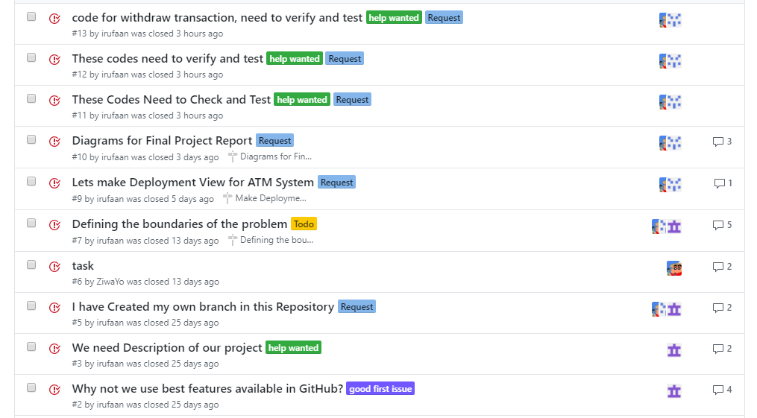
Figure 1: Issue page in GitHub – This image showing some of the tasks I opened and closed while us doing the project.

ATM System Description, Functional and Non-functional Requirement [1]

System Description

- Upon completion of a user’s transactions, the ATM returns to the idle state.
- If an error occurs, the ATM will automatically shut-down and return the card to the user.
- The ATM can be shut-down for maintenance and / or restarted to the idle state.
- A transaction may be canceled at any time before the transaction is sent and the necessary components of the system will be reset if the CANCEL button is pressed.
A main menu will be output to the display after validation of the PIN. The User selects one of six options representing a banking service. Namely, Withdrawal, Deposit, Transfer, Check Balance, Print transaction Record and Exit. Below is the ATM State diagram.
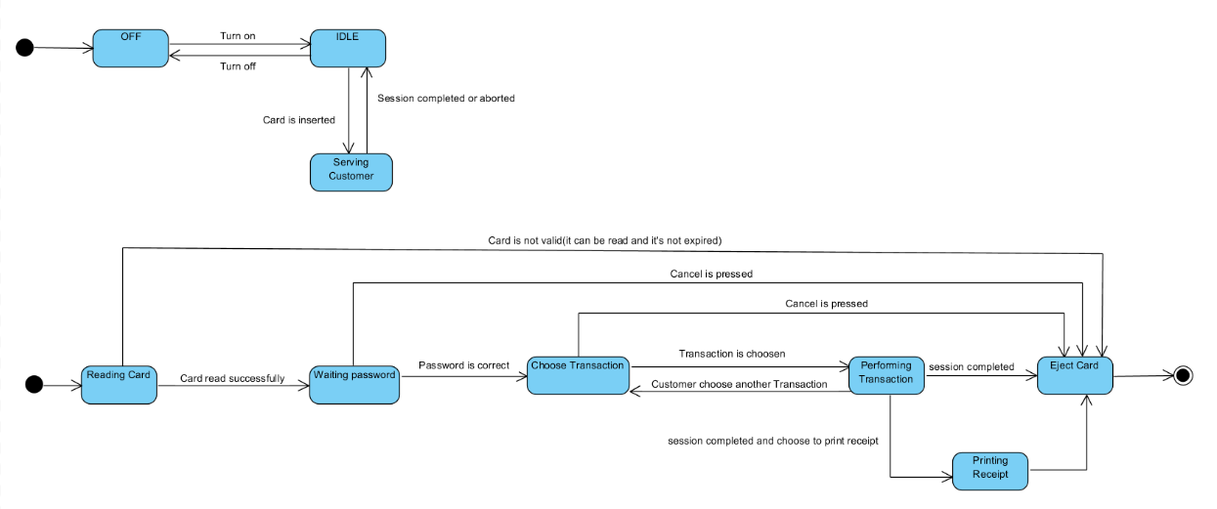
Figure 2 : ATM State Diagram showing idle state and User Interaction to ATM System.

Functional Requirement
It is the process of determining user expectations for a new or modified product. These features, called requirements, must be quantifiable, relevant and detailed. In software engineering, such requirements are often called functional specifications.
These requirements are observable tasks or processes that must be performed by the system under development. For example, a functional requirement of an automated teller machine, "must process withdrawals and dispense cash to the customer." Functional requirements are labeled FR-x. Where FR stands for functional requirements and x is a unique identifying integer.

ATM-FR-X | ATM Functional Requirement
ATM-FR-1 | The card reader determines the account number from the entered card.
ATM-FR-2 | The ATM is in the idle state when there is no operation.
ATM-FR-3 | The User is prompted to enter a PIN after a card is entered.
ATM-FR-4 | A menu is displayed to the User with the following options: Withdraw, Deposit, Transfer, Print transaction Record, Check Balance and Exit.
ATM-FR-5 | The cash dispenser has the ability to dispense cash
ATM-FR-6 | A transaction record can be printed upon demand
ATM-FR-7 | The card is ejected when the session is completed.
ATM-FR-8 | The ATM defaults to the idle state.
ATM-FR-9 | The cash dispenser is aware of the cash amount available.
ATM-FR-10 | The keypad accepts input from the User
ATM-FR-11 | The ATM can withhold a bank card
ATM-FR-12 | Transactions can be canceled at any prompt by the User pressing the CANCEL button.
Table 1: Table for ATM Functional Requirement

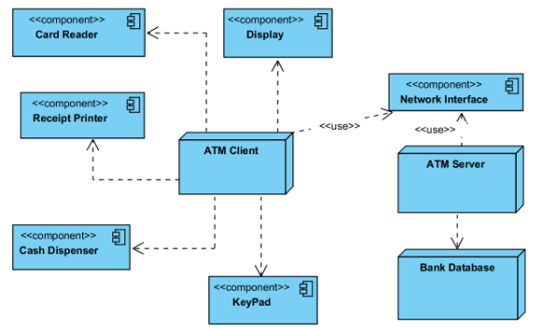
Figure 3: Deployment Diagram, This shows all the physical component of the Bank ATM system we did.

Non-Functional Requirement
These requirements are qualities or standards that the system under development must have or comply with, but which are not tasks that will be automated by the system. For example non-functional requirements for a system include: "system must be built for a total installed cost of RMB 1,00,000.00;","system must be secured against Trojan attacks."
Non-Functional requirements are labeled NFR-x. Where NFR stands for non-functional requirements and x is a unique identifying integer.

ATM-NFR-X | ATM Non-Functional Requirement
ATM-NFR-1 | The ATM unit consists of a display, a card reader, a cash dispenser, a keypad and a printer.
ATM-NFR-2 | The keypad is a set of buttons that includes the following: 10 buttons labeled with numbers 0 to 9, an OKAY button, a CLEAR button, a CANCEL button, and dynamic buttons that perform different actions.
ATM-NFR-3 | A PIN must be entered within 30 seconds.
ATM-NFR-4 | The User must enter the PIN correctly within three attempts
ATM-NFR-5 | ATM suspends further access using a particular card if the associated PIN is entered incorrectly 3 times in succession.
ATM-NFR-6 | The ATM must be secure.
ATM-NFR-7 | The ATM can be shut down and restarted
ATM-NFR-8 | The ATM defaults to the idle state.
ATM-NFR-9 | The cash dispenser can be opened and refilled with cash.
ATM-NFR-10 | The printer can be opened and refilled with paper.
Table 2 : Table for ATM Non-Functional Requirement

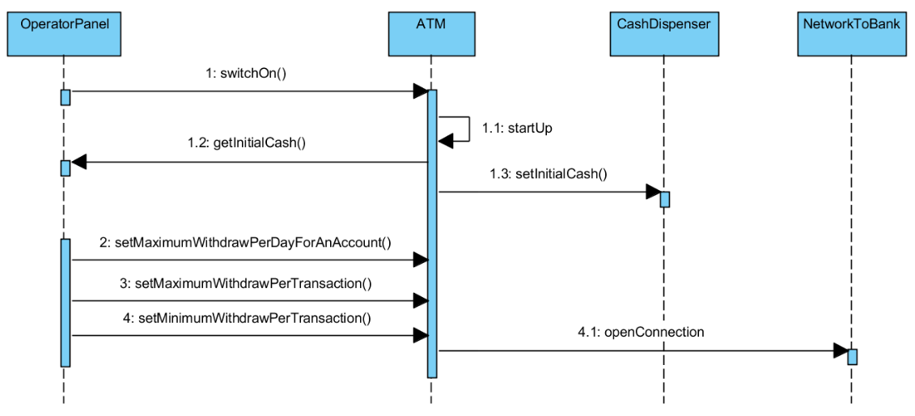
Figure 4: ATM Startup Sequence Diagram

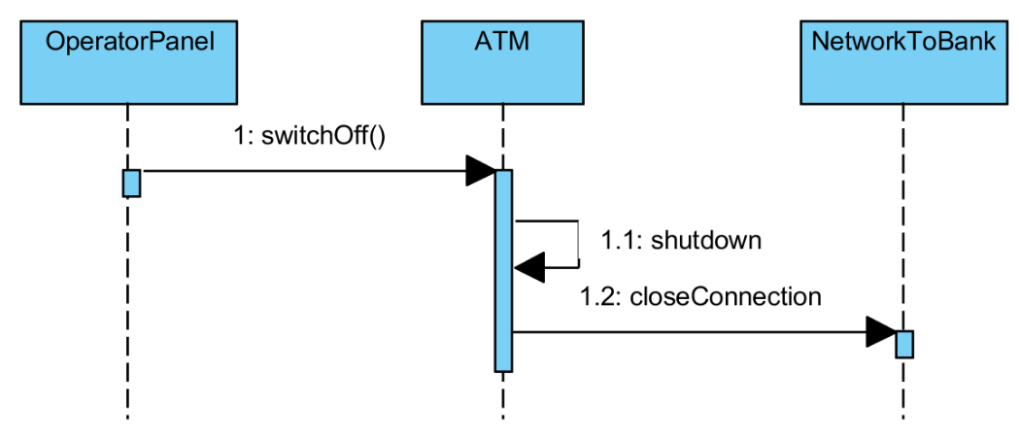
Figure 5: ATM Shutdown Sequence Diagram

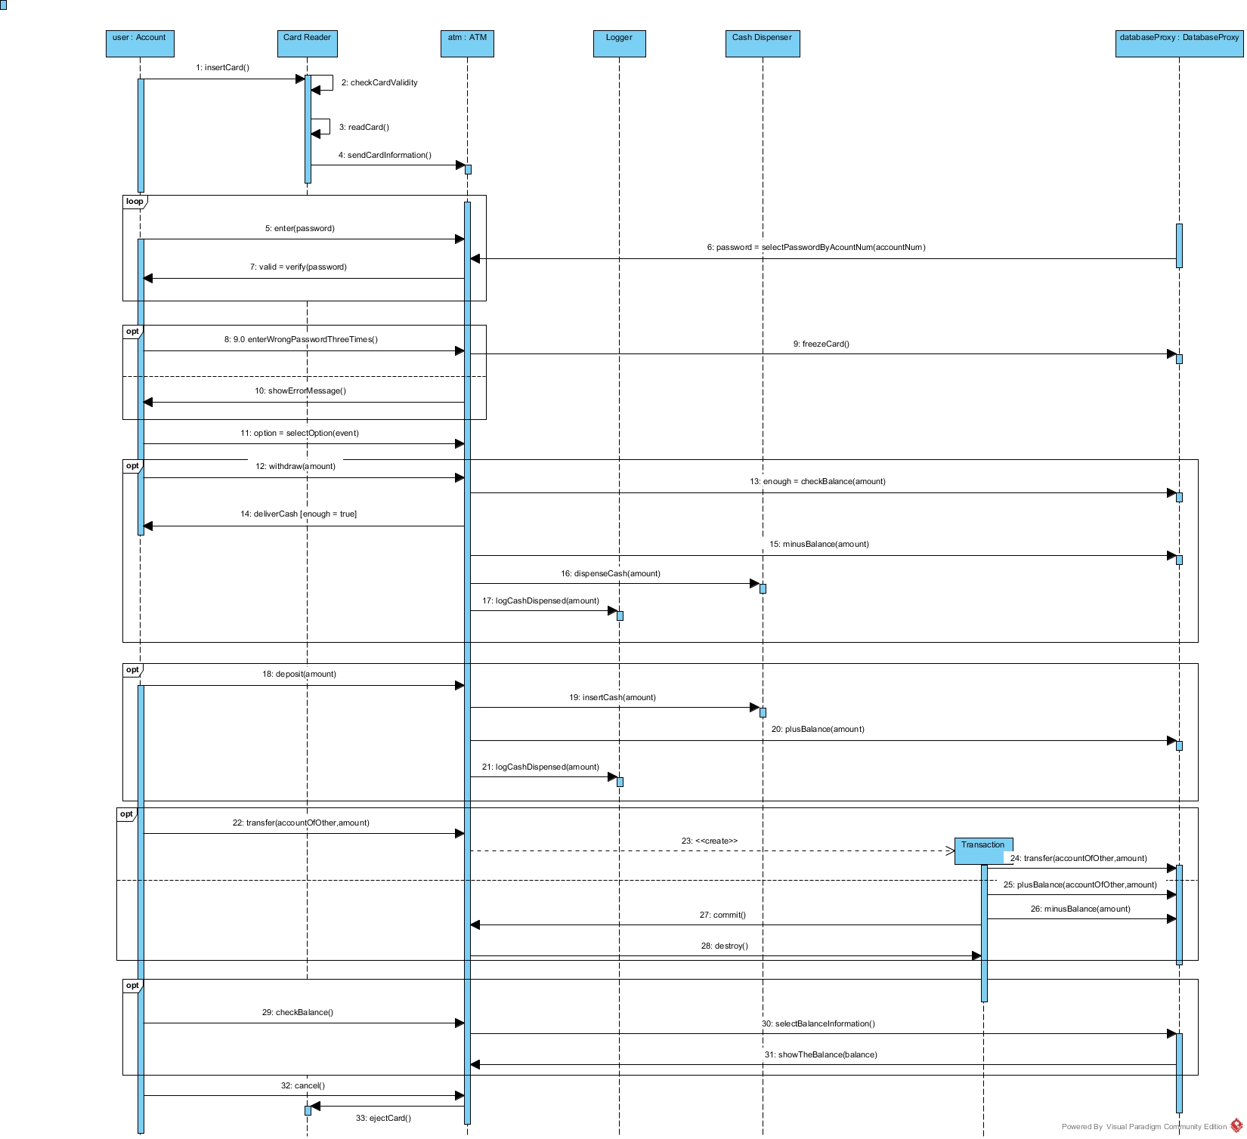
Figure 6 : Bank ATM Sequence Diagram

Work Breakdown Structure of the Team
After we plan the whole project then we breakdown the works into different tasks and assign the task according to the skills we have.
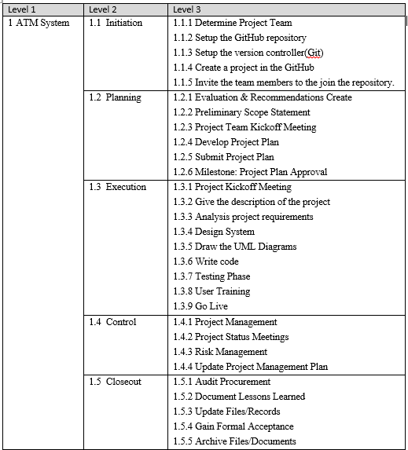
Table 3: Table of Breakdown Structure of our Team

After we breakdown the work load into small tasks then we create tasks in GitHub. In GitHub we discuss the problems and tasks. In GitHub I created Milestones for different tasks with deadline. Below is the one of the task I created in GitHub
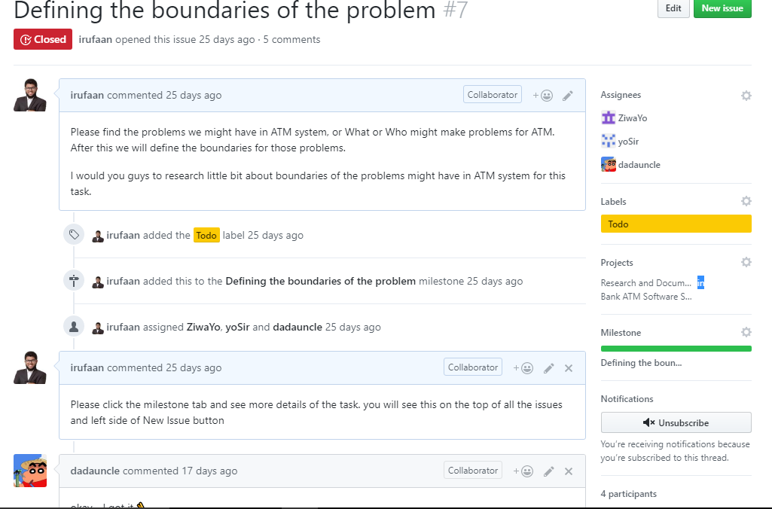
Figure 7 : One of the Task in GitHub

Conclusion
A conclusion section is not required. Although a conclusion may review the main points of the paper, do not replicate the abstract as the conclusion. A conclusion might elaborate on the importance of the work or suggest applications and extensions.
Appendix
Appendixes, if needed, appear before the acknowledg-ment.
Acknowledgment
The preferred spelling of the word “acknowledgment” in American English is without an “e” after the “g.” Use the singular heading even if you have many acknowledgments. Avoid expressions such as “One of us (S.B.A.) would like to thank ... .” Instead, write “F. A. Author thanks ... .” Sponsor and financial support acknowledgments are placed in the unnumbered footnote on the first page.
References
- Wajahat Gul, Student of Software Engineering at Comsats institute of information technology, Small Assignment about ATM System Description and functional and non- functional Requirements, https://www.slideshare.net/weje855/atm-system-description-and
- W.-K. Chen, Linear Networks and Systems (Book style). Belmont, CA: Wadsworth, 1993, pp. 123–135.
- H. Poor, An Introduction to Signal Detection and Estimation. New York: Springer-Verlag, 1985, ch. 4.
- B. Smith, “An approach to graphs of linear forms (Unpublished work style),” unpublished.
- E. H. Miller, “A note on reflector arrays (Periodical style—Accepted for publication),” IEEE Trans. Antennas Propagat., to be published.
- J. Wang, “Fundamentals of erbium-doped fiber amplifiers arrays (Periodical style—Submitted for publication),” IEEE J. Quantum Electron., submitted for publication.
- C. J. Kaufman, Rocky Mountain Research Lab., Boulder, CO, private communication, May 1995.
- Y. Yorozu, M. Hirano, K. Oka, and Y. Tagawa, “Electron spectroscopy studies on magneto-optical media and plastic substrate interfaces(Translation Journals style),” IEEE Transl. J. Magn.Jpn.,

 Student Name: Ali Irufaan Student Number: 201532120135 Student Email: irufaan0121@gmail.com Course Name: Object Orientated Analysis and Design (OOAD) Received December 25, 2017

